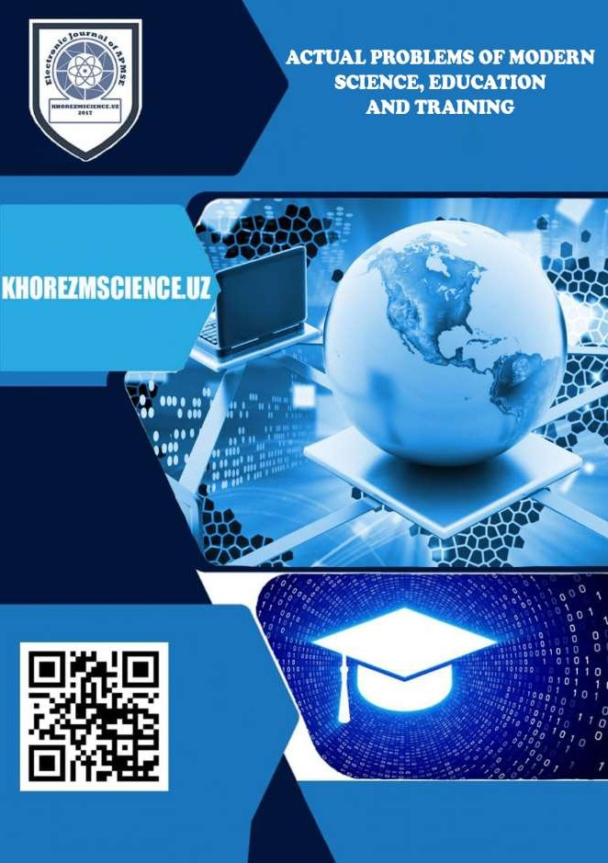

JABBOROVA GULHAYO FAXRIDDINOVNA /// CORPUS LINGUISTICS:

HISTORICAL AND LINGUISTIC ASPECTS 4

NOROV JAMSHID NURULLOYEVICH /// CRITERIA FOR THE CREATION OF THE NATIONAL CORPUS OF THE UZBEK LANGUAGE 8

BEGMATOVA RANO FAHRIDINOVNA /// SYNTACTIC CRITERIA AND SYNTACTICAL SIMILARITY AND PECULIARITIES IN THE STUDY OF DOWNLOADS IN GERMAN AND UZBEK LANGUAGES 12

MUSTAFAYEVA NILUFAR ULASHOVNA /// METHODS OF PREVENTION OF DYSLEX AND DYSPRACY IN THE DEVELOPMENT OF WRITTEN

SPEECH IN BILLINGUAL EDUCATION 18

FOZILOVA MOHIGUL /// THE CORRELATION OF TYPES OF SPEECH

ACTIVITY WITH SPEECH STYLE… 24

AKHMEDOVA AZIZA KOMILOVNA /// TYPOLOGICAL AFFINITIES IN

THE EXAMPLE OF TWO NOVELS… 28

ISTODA RASULOVA /// THE NATURE OF INTERFERENCE AS A PRODUCT OF LINGUOCULTURAL RELATIONS 32

TOSHPULATOVA MEHRINISO KILICHEVNA /// CORPUS INFLUENCED

MATERIALS IN TEACHING ENGLISH 39

ABRAYEVA SHAKHNOZA ESONOVNA /// APPLICATION OF LATIN AND GREEK SYNONYMIC MORPHEMES IN MEDICAL TERMINOLOGY OF

THE FRENCH LANGUAGE 45

ABDUGANIYEV OTABEK ALLAJONOVICH /// IMPROVEMENT OF THE METHODOLOGY OF ECONOMIC AND STATISTICAL ANALYSIS OF THE EFFICIENCY OF AGRICULTURAL PRODUCTS INCLUDED IN THE

CONSUMER BASKET 50

AKHMATOVA MOHIGUL ERGASH QIZI, HAMROYEV HALIM ROZIKOVICH /// USE OF INNOVATIVE TECHNOLOGIES TO IMPROVE THE QUALITY OF TRANSPORT SERVICES 54

MADIYAROV GAFURJON AKHMEDOVICH, BUZRUKSHAYEV HUSANHON ZIYOVIDDIN OGLI /// WAYS TO IMPROVE IT AND ACTIVITIES OF MARKETING OF NAMANGAN REGIONAL BRANCH

"QISHLOQ QURILISH BANK" 58

MAMATKABILOV ABDILMAJID KHUJAMURODOVICH /// MATHEMATICAL MODELS OF CURVED AND LINEAR MOTION OF A CAR TAKING INTO ACCOUNT THE ELASTICITY AND DEFORMABLE

TIRES 64

POLVONOV KHUDAYBERGAN KUZIYEVICH, ATANIYAZOV OTANIYOZ NURULLAYEVICH, RAZZOKBERDIEV NURBEK, SOBIROV KODIR, YULDASHEV SHOKIR URINOVICH /// INHIBITORY AND REGULATORY ACTIVITY OF SOME DERIVATIVES OF 5- EXCHANGED AMINO-1,3,4-

THIADIAZOLINE-2-TIONS 76

CHULIEVA VASILA ERKINOVNA /// THE ISSUES OF SPIRITUAL MATURITY IN JALAL AD-DIN RUMI’S VIEWS ON SPIRITUAL AND

MORAL VALUES 82

CHULIEVA VASILA ERKINOVNA /// THE ISSUES OF FAMILY STABILITY IN THE SOCIAL VIEWS OF JALAL AD-DIN RUMI 86

YUSUPOV AKHMADJON SHONAZAROVICH /// FROM THE HISTORY OF THE STUDY OF THE SAKS’ MONUMENTS IN THE LOWER SYR DARYA

BASINS… 90

GULCHEHRA GAFFAROVA /// MODERN PHILOSOPHICAL INTERPRETATION OF ABU RAYKHAN BERUNI'S SCIENTIFIC

IDEAS 95

KODIROV BARHAYOTJON SOBIRJONOVICH /// CONCEPTUAL FUNDAMENTALS OF INNOVATIVE DEVELOPMENT OF

UZBEKISTAN 99

UDK: 811.212.
APPLICATION OF LATIN AND GREEK SYNONYMIC MORPHEMES IN MEDICAL TERMINOLOGY OF THE FRENCH LANGUAGE

Abrayeva Shakhnoza Esonovna Tashkent medical Academy
Lecturer of uzbek and foreign languages
abrayevashaxnoza1990@gmail.com.
Annotatsiya. Mazkur maqolada fransuz tili tibbiy terminologiyasida lotincha va yunoncha sinonimik morfemalarning qo`llanilishi va fransuz tilidan o’zbek tiliga o’zlashgan baynalminal tibbiy terminlar xususida fikr-mulohaza yuritilgan. Bunda xalqaro, chetdan kirib kelgan zamonaviy tibbiy terminlarning so’zlashish jarayoniga kirib kelish sabablari, hamda foydali tomonlari haqida ma’lumot berilgan.
Kalit so`zlar: termin, tibbiy atama, iboralar, xalqaro so'zlar, sinonimik morfema, fransuz tili, lotincha va yunoncha so`zlar.
Аннотация. В этой статье обсуждается использование латинских и греческих синонимичных морфем во французской медицинской терминологии и межэтнических медицинских терминов с французского на узбекский. В нем представлена информация о причинах введения современных международных медицинских терминов, а также об их преимуществах.
Ключевые слова: термин, медицинский термин, словосочетания, интернациональные слова, синонимические морфемы, французские, латинские и греческие слова.
Annotation. This article discusses the use of Latin and Greek synonymous morphemes in French medical terminology and inter-ethnic medical terms from French to Uzbek. It provides information on the reasons for the introduction of modern, international medical terms from abroad, as well as their benefits.
Key words: term, medical term, phrases, international words, synonymous morpheme, French, Latin and Greek words.
Introduction. The adoption of the Law “On the State Language” by the Supreme Soviet of Uzbekistan on October 21, 1989 required a new approach to the terminological lexicon, which is one of the main layers of the Uzbek language vocabulary. We know that the Uzbek people have historically interacted with different peoples. These relations have had a significant impact on the Uzbek language. As a result of the interaction, the Uzbek language's vocabulary has increased due to economic, political and cultural ties. The reason for this, of course, goes back to historical processes. For example: the assimilation of their international words into the Uzbek language under the influence of many peoples (Iran, Macedonia, the Hephthalites, the Turkish Khanate) who invaded our country before the VII century (assimilation word - from one language to another) past tense) and its practical application among the population. The period after the VII century was directly influenced by the Arab invasion and domination of our country, which led to the influence of the Arabic language on our language and the acquisition of new words.
Since the second half of the 19th century, Central Asia, including Uzbekistan, has become a colony of Russia. have mastered.[2]

The introduction of words from Russian into Uzbek includes two historical periods:
- The period from the second half of the XIX century to the beginning of the XX century.
- The period after 1917.
Russian is taught in two main ways: orally (the process of communication between the various professions and the local population) and in writing (the process of newspapers, magazines, books, correspondence).
Literature review. According to G.V.Kolshansky, language functions simultaneously both as a product of a person's mental activity and as a form of this activity, and its existence must be based on the conformity (sufficiency) of the reflected objective reality to the mental language process. The great French philosopher and writer V.Gyugo said of the French language: “French is not a language that has stagnated and never will be. No tongue will be hardened, and tongues will sway like the sea. ”[5]
The authoritativeness of the donor language, the expressiveness of novelty, etc. also act as the most important reason for borrowing. The factor of the authority of the language is of great importance in borrowing precisely the Greek-Latin terms, since, as was revealed earlier, it was Latin that was the language of science, and a huge role in the development processes medical terminology belonged to foreign scientists.
MG Volkova, DO Kozlova, in turn, subdivide all the reasons for borrowing foreign-language lexemes into external and internal [4]. For external reasons, researchers attribute the presence of close trade, economic, political, cultural relations between the peoples who speak the languages. A huge role in the intensification of borrowing processes is played by the political role of the country and language, the constant appearance of new or rethinking of already existing words in order to need to nominate new realities, objects, processes of reality.
Research Methodology. First of all, it should be noted that a medical terminology system can be understood as a set of terms that act as a means of nomination of concepts, one way or another related to medicine, functioning in the professional medical field.
Today, the medical terminology system is one of the most developed and well- developed "in terms of distinguishing between doublet and synonymous formations" [1]. The specificity of the medical sphere of professional activity, the need to achieve optimal interaction, understanding between doctors requires bringing to the unification, standardization of the terms that are used in the communication process, as a result of which, despite the representation in national terminological systems of national lexical units and syntactic constructions, it is Greek-Latin borrowings the leading role is assigned. As a rule, such semantic units are understandable to specialists from different countries, do not cause difficulties in interpreting the meaning of the message, contributing to the optimization of interaction in the professional community. In other words, the main feature of the medical terminology system should be called its consistency and accuracy, "since a person's life depends on the unity of understanding the terms" [8].

Today, Greek-Latin terminology is, according to E.I.Zagrekova, the basis of medical vocabulary, successfully implementing the following functions [8]:
- plays the role of a system-forming factor, in other words, it is the terms of Greco-Latin origin that constitute the core, the basis of the medical terminology system. Greek-Latin terminology, according to the author, “is a thesaurus of medical science, that is, it includes all the basic concepts and terms of medicine, without the knowledge of which meaningful assimilation of special subjects of medicine is impossible” [1];
- denotes the basic concepts of medical practice, which ensures the optimization of interaction, unambiguous understanding of the content of communication.
Accordingly, today the medical terminology system is one of the most developed, aimed at increasing efficiency, optimizing the interaction between physicians in the professional field.
Analysis and results. In linguistics, particularly etymology, lexicology, and comparative linguistics, the term “borrowing” refers to the process of inserting a term from another language into a lexicon for a language. The word assimilation can be direct or indirect. Assimilation is one of the tools for speakers to increase their vocabulary, along with neologisms and derivations. The word assimilation is passed from one language to another due to certain socio-historical events, trade and cultural connections. For example:
- Persian-Tajik medical terms - filzahra (stomach ache), tabgirifta (increased blood pressure),
- Medical terms borrowed from the Arabic language - tutqanoq (nervous disease), moxuliyo (melancholy disease), lojuvard (mineral substance), yaraqoni asvad (jaundice)
- Russian medical terms - мигрень (migraine - headache),
Words are the result of relations between nations and states. As a result of the annexation of Central Asia to Russia, Russian and European words were introduced into the Uzbek language. Words entered from Russian and other languages through the Russian language are used in socio-political life, industry, agriculture, science and technology, medicine, art, trade, sports, military, with almost unchanged phonetic aspects. Words are international words.
Similar adjectives are also found in French. Such words are initially neologistic in nature, and then gradually follow the rules of language:
- Phonetic formation:
- artère (nf) → артерия → arteriya;
- xérophtalmie (nf) → ксерофтальмия → kseroftalmiya
- By adding:
- amibe (nf) → амеба → amyoba + lar
- anti+acide (nf) → антацид → antatsid+lar
- Assimilation by shielding:
- lèvre de lièvre → губы зайца → quyon lab
- fente palatine → волчья пасть → bo’ri og‘iz
- Adaptation of the learned word:
- bronchite (nf) → бронхит → bronxit;

- bactérie (nf) → бактерия → bakteriya;
d) coma (m) → кома → koma;
- The fact that it is a memorized word due to repeated use:
- allergie (nf) → аллергия → allergiya;
- épidémie (nf) → эпидемия → epidemiya;
- grippe (nf) → грипп → gripp;
- coronavirus (m) → коронавирус → koronavirus
- Assimilation of international (international) words related to the profession and field:
- anatomie (nf) → анатомия→anatomiya
- dermatovenereologie (nf) → дерматовенерология → dermatovenerologiya d) oto-rhino-laryngologie (nf) (ORL) → отоларингология (ЛОР) → otorinolaringologiya
- réanimation (nf) → реанимация → reanimatsiya.
Words are the result of relations between peoples and nations. The history of the Russian language shows the cultural, economic and political ties with other peoples, during which the multiplicity of words adopted from the Russian language is strengthened. This process of mastering the words adopted by the Russian language is a positive event, it enriches the language to make it more capable and advanced. This is a common occurrence and even inevitable at certain times.
The Russian dictionary consists of two main groups: 1) words of language ancestors and 2) words from other languages. The acquisition of foreign words is one of the developmental processes of modern language, which is the result of the interaction of elements from one language to another, or they themselves are elements transferred from one language to another.
There are two ways to learn a language: oral and written. Extralinguistic reasons for learning include:
- historical ties of peoples;
  - the need to name new objects and new concepts;
  - Innovation of the nation in some specific areas of activity;
  - fashion, cruelty of language;
  - Economics of language resources; authority of the source language;
  - the proliferation of different social strata for historical reasons, to meet a new word;
- The influence of one culture on another.
Conclusion. It is important to note that these reasons, as a rule, do not exist separately; in most cases, the initiation of borrowing a foreign-language lexeme is determined by a whole complex of reasons and factors.
Accordingly, on the basis of the study, it can be concluded that the medical terminology system is a set of professionally marked lexical units and syntactic constructions, one way or another related to the peculiarities of the implementation of professional activities in the field of medicine, which are used in the process of communicative interaction in the professional community. The main difference of the terminological system is the high degree of its elaboration, accuracy, and uniqueness of terminological units. In the process of its formation, the term system has passed a

long path of historical development, moreover, since ancient times, Greco-Latin borrowings have played a huge role in the formation of the studied term system. At the heart of the appeal to Greco-Roman terms is a whole complex of extralinguistic, intralingual and socio-psychological factors, features of historical development. In conclusion, such terms, which are considered important for medicine, play an important role in our daily lives. At the same time, in a pandemic, medical terms are the most actively used vocabulary in our speech activities.

References:
[1]. Abu Ali ibn Sina "Medical advice" T. "Labor" 1991, p: 3.
[2]. Natalia Grabar «Terminologie medicale et morphologie. Acquisition de ressources morphologiques et leur utilisation pour le traitement de la variation terminologique». en 2004 à Paris 6 .
[3]. Borovkova Natalya Nikolaevna, Baykova Anna. « Les emprunts français dans la langue russe moderne. Les raisons de la baisse des emprunts français dans la langue russe moderne». ГБОУ gymnasium № 505, Moscow,2013 ;
[4]. H.A. Dadaboyev «Terminology of the Uzbek language», T., 2016. p: 10; [5]. Kolshanskiy G.V. «Paralinguistics». Paperback: - January, 1, 2017.
[6]. Abduzuhur Abduazizov. "From languages to languages" 2013: - 26th issue of the newspaper of literature and art of Uzbekistan;
[7]. Françoise Kern-Coquillat « Dictionnaire des termes medicaux de 1914-1918 ». Crid 14-18, 2010 ;
[8]. Zagrekova E. I. Istoki i razvitie rossiyskoy meditsinskoy terminologii (na greko- latinskoy osnove): Avtoref. diss. kand. filol. science. - Saratov, 2008. - 23 s. - S. 6 [9]. Agafonov A.N. , Agafonov V.A. Etimologiya i semantika nekotoryx meditsinskix terminov greko-rimskogo proisxojdeniya // Vestnik Smolenskoy gosudarstvennoy meditsinskoy akademii. -2018, T. 17, № 4. - S. 182 - 192. - S. 183.

